Capstone Project Report: Full-Stack MERN Blog
1. Implementation Overview
The project is a full-stack blogging platform built using the MERN (MongoDB, Express, React, Node.js) stack. It features a secure authentication system, a community feed with search capabilities, and a personalized user workspace.
- Frontend: Developed with React.js, utilizing react-router-dom for navigation and axios for API communication. Styling was implemented using CSS variables and inline JavaScript objects to support a dynamic Dark/Light mode.
- Backend: A Node.js and Express server providing a RESTful API.
- Database: MongoDB (Atlas) used for persistent storage of Users and Posts.
- Authentication: Implemented using JSON Web Tokens (JWT) stored in localStorage to maintain user sessions across page refreshes.

2. Key Features
- User Authentication: Secure Registration and Login with password hashing (Bcrypt) and JWT-based protection for "Create" and "Edit" routes.
- CRUD Operations: Users can Create, Read, Update, and Delete their own posts while having read-only access to the community feed.
- Real-time Search: A debounced search bar in the PostList allows users to filter stories by title or author without overloading the API.
- Responsive Design: A minimalistic, mobile-friendly UI that adapts to system theme preferences.

3. Challenges Faced
- State Synchronization & Persistence: One major challenge was ensuring the "Logged In" state persisted when the user refreshed the browser. I solved this by checking for a valid token in localStorage within the App.js initial state.
- JavaScript ReferenceErrors: During development, several components (like Login and CreatePost) failed to render, resulting in a blank screen. This was traced back to style objects being accessed before they were defined. I resolved this by moving style definitions to the top of the component files, ensuring they were in scope during the render phase.
- Ownership Verification: Ensuring users could only edit their own posts required careful comparison between the currentUserId in the frontend and the author ID returned by the MongoDB populated object. I implemented a robust check using String() conversion to ensure ID matches were accurate.

4. Key Learnings
- Component Lifecycle: Deepened my understanding of useEffect for data fetching and the importance of dependency arrays to prevent infinite loops.
- API Design: Learned how to structure RESTful endpoints (GET, POST, PUT, DELETE) and handle error responses gracefully to provide clear user feedback.

5. Future Enhancements
- Image And Video Uploads: Along with the written part people can add their picture and videos share their emotions.
- Interaction: Adding a "Likes" and "Comments" system to increase community engagement.
- Add to favourites: There can be separate columns for adding their favourite blog post to see it again or to see it later.
- Channels: Just like other social media platforms user can make their own channel and gain subscribers.

NEW CHANGES:

1. Core Backend Infrastructure
You successfully established a secure foundation using the MERN stack.
- Authentication: Implemented stateless authentication using JWT and secured passwords with bcrypt.js hashing.
- Data Modeling: Established relational mapping where posts are linked to authors via MongoDB ObjectIDs.
- Route Protection: Developed a custom verifyToken middleware to secure sensitive CRUD operations.
2. Content Discovery & Dynamic Feed
Your frontend now features an interactive and efficient content delivery system.
- Dynamic Routing: Implemented dynamic :id parameters in routes (e.g., localhost:3000/post/69a9...), allowing for individual story rendering.
- Advanced Search: Built a MongoDB Aggregation Pipeline using $lookup and $match to enable real-time searches across both post titles and author names.
- Performance Optimization: Integrated debounced API calls with a 500ms delay to reduce unnecessary server load during searches.

3. User Experience & Theming
The screenshots show a modern, reactive UI that adapts to user preferences.
- Theme Switching: Created a global CSS theme state with a switcher that toggles between light and dark modes (☀️/🌙).
- Personalization: The Navbar.js now dynamically greets the user by name (e.g., "Hi, hello") using data retrieved from localStorage.
- Visual Identity: Added a circular avatar section that extracts and capitalizes the first letter of the user's name.
- Interactive Polish: Enhanced the UI with card hover effects (translateY(-4px)) and a sticky header for improved navigation.

4. Security & Content Lifecycle
You have ensured that users can only interact with content they are authorized to manage.
- Ownership Controls: The UI conditionally renders 'Edit' and 'Delete' triggers only for the authenticated creator of a post.
- Session Management: Developed a clean logout function that clears user data from localStorage and safely redirects to the login page.
- Safety Patterns: Integrated confirmation dialogues for destructive actions to prevent accidental data loss.

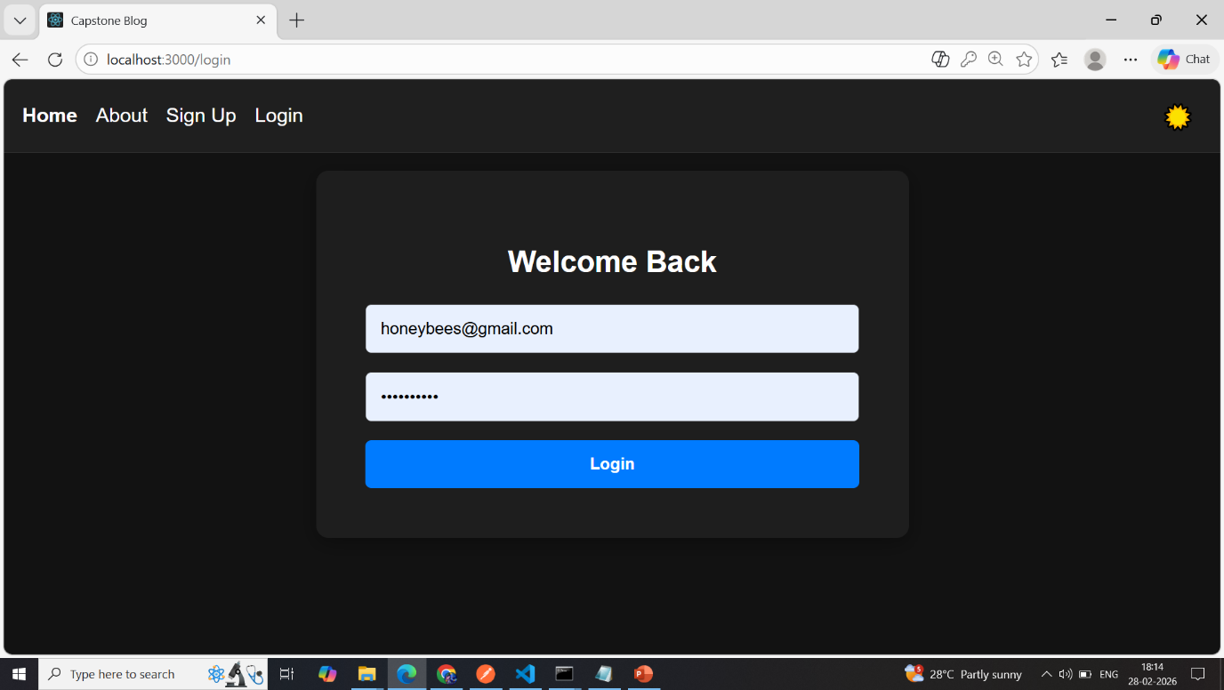
EVIDENCE

